[1]

Characterization of Reflectors in a Wireless Channel to Aid Low-Power Indoor Localization

Aidan Smyth

*Abstract*— Modern wireless communication systems for the Internet of Things (IoT) increasingly require both long battery life and accurate indoor localization. Bluetooth Low Energy is heavily adopted in emerging wireless sensor networks as it meets the energy constraints. However, reflectors present in an indoor wireless channel cause multipath fading at the receiver, reducing accuracy and increasing the required energy for accurate indoor localization. Characterizing reflectors in a wireless channel can greatly enhance the accuracy of such low-power indoor localization systems. This paper proposes a low-energy approach to characterizing the wireless channel using power delay profiles (PDPs) and several novel ray tracing techniques which are implemented to verify the PDPs and predict the location of a reflector in an indoor wireless channel.

The selected solution successfully generates low-energy PDPs for several indoor positions, which are processed using ray tracing scripts to identify and verify a suspected reflector in the indoor environment.

# INTRODUCTION

T

HE key research question investigated in this paper and subsequent literature review is the following:

*“Which wireless technology and propagation model can provide the best trade-off between high accuracy and low computational cost for the characterization of a reflector in a wireless channel?”*

Use of the Global Positioning System (GPS) complimented with cellular provides precise positioning information outdoors [1]. Despite its popularity and accuracy outdoors, GPS suffers strong attenuation when passing through walls and is not sufficiently accurate indoors [2] [3]. In [4] it was stated that GPS systems “are not perfect as they rely on faint radio signals that can be blocked or reflected by man-made structures”. Wireless technologies such as Wi-Fi, Bluetooth or ZigBee are all competing to be the default implemented solution for indoor localization applications.

One of the main challenges faced by wireless technology indoors is the presence of reflectors in the wireless channel. In both line-of-sight (LoS) and non-line-of-sight (NLoS) transmitter-receiver situations, a source of error is the reflection of signal caused by reflectors in the channel. These reflectors crate delayed multipath signals which can cause interference at the receiver. Characterizing the wireless channel and its reflectors enables integration of this normally troublesome multipath signal as useful data to enhance the accuracy of indoor localization systems.

A diverse set of modern indoor localization applications exist which require submeter accuracy in harsh propagation environments. These include security, presence detection, automotive, medical services, logistics, emergency services, smart home appliances and military systems [5]. IoT technology avails of wireless sensor networks (WSNs) that require a long battery life to reduce the frequency of costly maintenance. As a result, indoor localization systems should target low energy consumption.

In this research, Bluetooth Low Energy is chosen to perform frequency sweeps of the wireless channel at several indoor locations as it best satisfies the low-energy constraint. Note that NLoS scenarios are not in the scope of this investigation. The proposed solution uses the PDPs obtained from these frequency sweeps as inputs to two different 2D ray tracing models. The first ray tracing model takes the real-world PDPs obtained from frequency sweeps at several positions in a room and verifies that they match the expected PDPs generated during a ray tracing simulation for a known geometry and reflector. The second ray tracing model has no prior knowledge of the indoor geometry, and uses each real-world PDPs to generate a locus of possible reflectors in the wireless channel. The intersection of several PDP’s locus indicates the location of a suspected reflector in the room.

The literature review in XXX documents in detail the technical background, existing research, project development and results. This paper is the centre-piece of the research portfolio, and presents a focused summary of the literature review. It describes the leading-edge research in the field, a technical description of the technology and theory applied to the problem, analysis of the investigation’s findings, and the author’s conclusions and proposals for future research.

# Existing Research

Different approaches outlined in this section have been implemented for wireless indoor localization, many achieving satisfactory accuracy. Since energy consumption is a constraint, recent research is focused on also implementing low-energy solutions [6].

## Estimation Techniques

There are several popular localization techniques for analyzing received signals. Received signal strength (RSS) models the path loss of the signal over distance transmitted. The primary disadvantage of RSS is that it performs poorly in indoor environments where other propagation phenomena distort the relationship between distance and received signal [5]. Angle of arrival (AoA) estimation determines the angle of incidence at which signals are received by antenna arrays. High resolution AoA solutions require large antenna arrays, therefore accurate AoA localization is energy inefficient and costly to implement. AoA is also limited by the fact that it requires strong LoS conditions [7] [8]. Another multiple antenna solution is time difference of arrival (TDoA), which pairs antennas and triangulates using the delay time each antenna experiences relative to a reference anchor [9]. Wi-Fi incorporates a similar approach, “Finite Time Measurement”, using the round-trip time to estimate the distance to the receiver [10].

Each estimation technique implemented in isolation fails to characterize multipath components or reflectors, an essential requirement for low-energy accurate sub-meter indoor localization.

## Wireless Technology

Numerous low-energy wireless technologies have shown promise in indoor localization applications [11]. BLE is the most popular IoT wireless technology due to its short range, small data rate and low power consumption. ZigBee and ultra-wideband (UWB) signals have made less of an impact in industry and research primarily due to the fact that both are more costly and less energy-efficient than BLE [12]. However, in applications where energy efficiency and cost are not hard constraints, UWB provides the best resolution and most accurate indoor localization solutions [8] [13].

Research in [12] investigates the low-energy performance of BLE in contrast to ZigBee. The study indicates that BLE is highly energy efficient in terms of number of bytes transferred per Joule, but could be improved by increasing the data rate per connection event and implementing adaptive frequency hopping to combat interference. Opportunistic listening [11] can leverage responses from other devices’ requests to allow sharing of the channel among scanning devices.

## Indoor Localization Techniques

Multipath can be detected using delay times and anchor receivers in a known room geometry in [14], assisting indoor localization by characterizing the wireless channel. Machine learning techniques can be applied to existing wireless communications structures, motivating the continued research in this area. Machine learning enhances indoor localization and characterizes multipath in a wireless channel in [1] [2]. Both of these experiments use BLE technology.

## Automotive Applications

The automotive industry relies on WSNs to provide real-time data on peripherals and essential features. Research in [15] declares BLE as the industry’s leading technology for maximizing the energy-latency trade-off in automotive applications. Passive Keyless Entry (PKE) is explored in [16] using a Cypress Semiconductor Programmable System on a Chip (PSoC), with a BLE peripheral as the host and the user’s smartphone as a client.

## Propagation Models

Propagation modelling aims to obtain an estimation of field strength given a set of parameters from the wireless channel [17]. Propagation models can be classified into two categories: deterministic or empirical models.

Deterministic models use Maxwell’s equation along with detailed information about the environment. Deterministic models compute highly accurate PDPs and do not require local measurements. A drawback is that they require high computational effort [18]. A ray tracing model is an example of a deterministic model. A 2D ray tracing model is implemented in [19] to identify unmanned aerial vehicles flying in an urban environment. A wireless channel can be simulated using beam-forming and other deterministic methods in [20] and [21] respectively, with both predicting effects such as multipath propagation accurately.

Empirical propagation models are more widespread that deterministic models due to their simplicity and speed. Examples include the COST231 and Motley-Keenan models compared in [22]. Empirical models require less environment data. This reduces the computational effort and produces simplified mathematical expressions to calculate path loss between the transmitter and receiver [18]. However, empirical methods are limited by the fact that they are range-based and are valid only to similar environments [17]. Empirical models can be enhanced to include greater detail (wall thickness etc.) as shown in [18], but they still lack the accuracy and complete PDPs generated by deterministic models.

# Technical Description

An overview of the theory implemented in this research is presented in this section, providing the reader with insight into the results and analysis that follows in later sections.

## Hilbert Transform

Direct measurements of the phase during the frequency sweep may be avoided by using the Hilbert transform to extract the phase response from the measured magnitude response. This is true only if the channel is minimum-phase [23]. Experience dictates that in scenarios where LoS is present the channel can be confidently assumed to be minimum-phase. The advantage of not directly measuring phase is the ability to characterize the channel using low-energy and low-cost instrumentation.

Hilbert transformers shift all positive frequency components by π/2 radians and all negative frequency components by -π/2 radians [24]. In the (1) it is shown that if $h[n]$ is assumed to be real and casual, the Hilbert transform of the real part of an analytic signal produces its imaginary part,

|  |  |  |
| --- | --- | --- |
|  | $$H\left(ω\right)=H_{R}\left(ω\right)+{jH[H}_{R}(ω)]$$ | (1) |

where $H$ denotes the Hilbert transform operation, defined by a convolution in (2).

|  |  |  |
| --- | --- | --- |
|  | $${H[H}_{R}(ω)]=H_{R}\left(ω\right)⨂\left(\frac{-2}{ω}\right)$$ | (2) |

This research implements a Hilbert filter (using the optimal Parks-McClellan approach) to convert the natural log of the magnitude response to the phase response (3). A FIR filter with a passband from 0.1 to 0.9 normalized frequency sufficiently models the Hilbert transform, and is shown in Figure 1.



Figure 1 - Hilbert filter magnitude frequency response.

If $\hat{h}(n)$ is assumed minimum phase, then it is also causal, giving the Hilbert relation to the phase and the wireless channel frequency response characterization (4).

|  |  |  |
| --- | --- | --- |
|  |  | (3) |
| and |  | (4) |

## Power Delay Profile

The power delay profile represents the distribution of signal power received over a multipath channel as a function of time, also referred to as the spatial average of the impulse response [25]. It can be obtained from the frequency response using the Inverse Fourier Transform (5).

|  |  |  |
| --- | --- | --- |
|  | $$H(ω) → F^{-1}→ h(t)$$ | (5) |

The signal power of each multipath is plotted against their corresponding propagation delays. The multipath component typically sees destructive interference as it propagates through the channel, i.e. increased channel loss. The PDP provides useful information that characterizes a wireless channel and helps identify multipath components to assist indoor localization [25].

An alternative way to consider the PDP is as the sum of $c_{i}$ ray paths in the time domain, that reach a receiver with different delay times $τ_{i}$ (6).

|  |  |  |
| --- | --- | --- |
|  | $$h\left(t,τ\right)=\sum_{i=1}^{N}{c_{i}(t)δ(τ-τ_{i})}$$ | (6) |

This representation in (6) is the basis for PDP generation from ray tracing simulations. The selection of N taps depends on the wireless channel’s coherence time $τ_{rms}$, and the number of signal paths present [26].

The PDP consists of three separate components: direct path, reflected paths, and noise. Each peak represents a ray path that reaches the receiver. The reflections that occur in a room can be characterized as specular or diffuse. Typically, the PDP becomes diffuse after the early multipaths at the receiver. Since reflections tend to scatter instead of being ideally specular, the number of reflections grows exponentially. Reflections cease carry important information as they attenuate [27].

## Ray Tracing

Ray tracing is based on the ray concept from the Geometrical Theory of Propagation, an extension of geometrical optics to radio frequencies. Ray tracing methods derive models for wireless channel prediction [17] [28]. A previous limitation of ray tracing was its high computational effort. This concern is less relevant today due to increased computing capacity available in modern computer networks [28]. The principle of ray tracing is to emit rays from a source, recursively reflect the transmitted rays toward the receiver, then follow the paths of each ray. The reflected paths that reach the receiver within the coherence time are stored as valid paths.

The first 2D ray tracing model designed in this paper simulates the multipath distributions of an indoor environment with a known geometry. Reflectors are defined as straight lines, and multipath reflections are modeled on AoA and angle of departure (AoD) theory at the reflector surface. The program’s output is a series of simulated PDPs, using the speed of light and length of ray path to create the delay times. The PDPs verify the delay times of the other PDPs obtained from the Hilbert transform and frequency sweep in the previous sub-section.

The second ray tracing solution in this paper implements a novel solution to identify or verify reflectors in a room with no prior knowledge of the geometry, using only real-world PDPs as input. Based on the multipath delay times, a locus of possible reflector locations is generated for each PDP, and where they intersect suggests that a common reflector may exist. The reflector geometry considerations are illustrated in Figure 2.

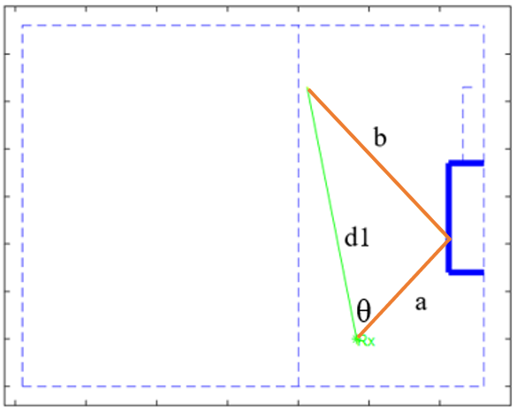

Figure 2 – Geometry used to characterize a potential reflector.

# Experiment Plan

## Data Acquisition

Five locations are chosen in an indoor auditorium to perform frequency sweeps of the 2-3 GHz frequency channel (see Figure 5). The receiver (signal analyzer) is fixed and the transmitter (signal generator) changes position for each different sweep.

## Automated Instrument Program

The receiver and transmitter need to sweep the frequencies in a coordinated and automated manner. This is achieved by scripting control of the signal generator and signal analyzer using the PyVISA package (Section XX). The signal generator is connected to the laptop via a GPIB-USB connection and the signal analyzer uses an Ethernet connection to communicate to the network. The signal generator sweeps in steps of 500 kHz while transmitting at a constant power of -14 dBm, strong enough to overcome most weaker signals competing in the channel. Simultaneously the signal analyzer sweeps the same frequency steps, storing the averaged peak value of the received signal magnitude in a CSV file.

## PDP Generation and Ray Tracing Simulation

The frequency sweeps measured at each location are post processed to generate PDPs for each position, using the MATLAB script in XX. The script is based on the theory in Section III, using the Hilbert filter to acquire the phase response of the channel from the magnitude response. The complete frequency response is reconstructed from the phase and magnitude response, and the Inverse Fourier Transform produces the time-domain PDP representation. From observing the common peaks in the PDPs, the delay times for the LoS and multipath components can be determined.

# Experimental Results and Analysis

## Channel Frequency Magnitude Response

The positions with longer transmission distances suffer larger path loss than those with shorter transmission distances. For all positions there exists a tap in all the magnitude frequency responses typically between 2.1-2.2 GHz. The positions with longer transmission distances all display several smaller taps and magnitude frequency response variations. The magnitude frequency responses can be found in XX.

If the signal generator is not transmitting, a frequency sweep can be performed using just the signal analyzer to observe channel noise. The noise measurement in Figure 3 show a large noise signal in the channel in the 2.4-2.5 GHz range strong enough to interfere with the signal at the receiver. Smaller narrowband signals are also present, but are easily overpowered once transmission begins.

A screenshot of a social media post

Description generated with very high confidence

Figure 3 - Manual sweep of channel noise.

## PDP Analysis

To avoid the unwanted noise in the channel characterization, the effective bandwidth is reduced from the 2-3 GHz swept to 2.0-2.4 GHz. The decision to take the lower half of the bandwidth is arbitrary, from 2.5-3 GHz is equally effective.

The PDPs generated for all five sweeps positions can be found in the XX. Each PDP has a clear LoS pulse of high path loss amplitude. Transmission positions further away from the receiver experience greater relative path loss (i.e. have a greater amplitude) than those closer to the receiver.

The scope of this investigation focuses on the most dominant multipath reflection since it has the strongest path loss and likely originates from the strongest reflector in the channel. The PDPs at the transmitter positions 1 and 3 do not experience any common multipath path that positions 5, 7 and 9 do, so are disregarded in the following multipath investigations.

Figure 4 compares the PDPs for remaining positions. The common multipath pulses are observed in the purple box. Significant noise in the PDPs makes it difficult to determine where the first multipath pulses exists. This noise is mostly attributed to Gibb’s phenomenon. According to [29], the phenomenon is an overshoot of Fourier series occurring at simple discontinuities.

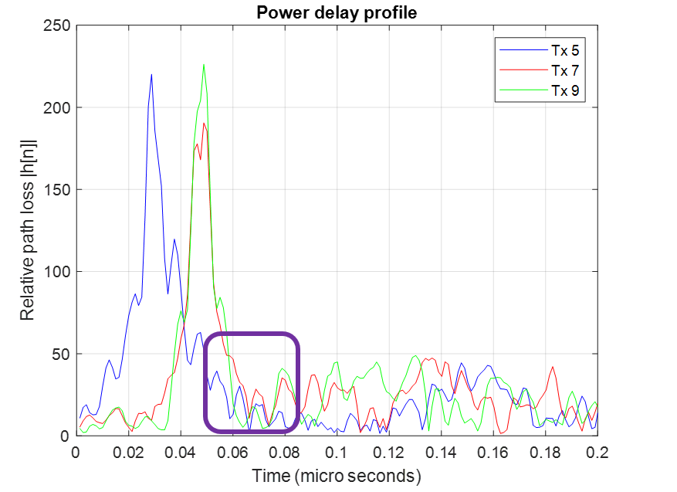

Figure 4 – PDPs comparison for positions that experience multipath.

Figure 5 compares the purple box region of the three PDPs, using the logarithmic scale to circle the first multipath pulses. Comparing the PDPs of the three nearby transmitter locations reveals that there is a common multipath pulse between the PDPs. The delay time of this pulse varies slightly depending on PDP location.

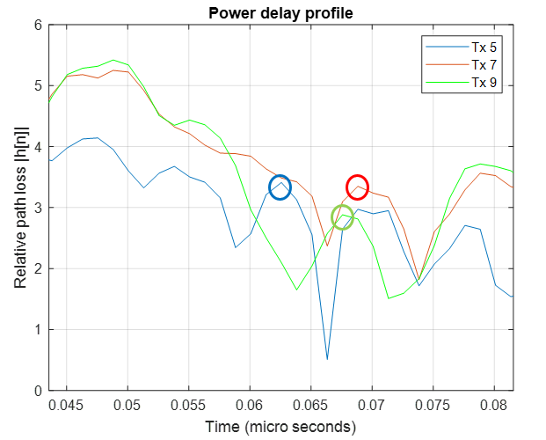

Figure 5 - Closer inspection of log PDP comparison.

The PDP observed delay times are listed in Table 1.

|  |  |  |
| --- | --- | --- |
| Position | LoS (µs) | Reflected (µs) |
| 1 | 0. 01877 | NaN |
| 3 | 0.01877 | NaN |
| 5 | 0.02879 | 0.06258 |
| 7 | 0.04881 | 0.06884 |
| 9 | 0.04881 | 0.06758 |

Table 1 – PDP time delays observed from sweep measurements.

## Validating PDPs Using Ray Tracing

The objective of the ray tracing program in this section is to verify or predict the PDPs captured in the previous section (Table 1). The outputs for all five positions can be found in XXX. Figure 6 displays the ray tracing simulation for transmission from position 7. Note that the co-ordinate system is in inches, but is converted to meters for PDP delay time calculation.



Figure 6 - Ray tracing simulation for transmitter position 7.

Table 2 lists the ray tracing generated PDP delay times. Note that positions 1 and 3 do not receive a multipath reflection, matching their PDPs measured in the previous section.

|  |  |  |
| --- | --- | --- |
| Position | LoS (µs) | Reflected (µs) |
| 1 | 0.016467 | NaN |
| 3 | 0.016763 | NaN |
| 5 | 0.028363 | 0.052372 |
| 7 | 0.046306 | 0.055463 |
| 9 | 0.046412 | 0.071667 |

Table 2 – PDP time delays from ray tracing with one reflector.

For the LoS paths, both ray tracing and measured PDP delay times match closely. This verifies that a reflector exists in the wireless channel where it is suspected (the elevator shaft). The measured PDP time delays are slightly slower (~2 ns), possibly due to possible attenuation and energy reduction.

The multipath reflection varies more (~9 ns), with position 9 experiencing especially long multipath delay in the ray tracing compared to the other positions. Possible reasons for this may be an unknown second reflector influencing the transmitted signal at position 9, or incorrect identification of PDP multipath delay times.

## Identify the Reflector Using Ray Tracing

The next part of the research is a novel to attempt to identify a reflector in an unknown indoor geometry. To first test the functionality of the script, the ray tracing PDPs in the previous section are used as an input (see Table 2). The ray tracer produces a locus of points whose geometry correctly match the distances suggested by the delay time inputs. In Figure 7 two loci intersecting correctly identifies the reflector to an accuracy of less than a meter.



Figure 7 - The PDP delay times generated using the ray tracer for a known reflector.

With the script correctly estimating the known reflector for ideal ray tracing PDPs, the next step is to use the real-life measured PDPs as an input (Table 1). Less accurate prediction is expected compared to the results in Figure 7, due to multiple possible reflectors indoors, incorrect identification of the multipath delay time, and the fact that a 2D simulation does not model the real-life 3D environment.



Figure 8 – Ray tracing reflector estimation for measured PDPs

In Figure 11, two of the reflector position loci intersect in the region where the elevator shaft is (indicated with a blue rectangle). This confirms that the suspected reflector exists in that region, adding greater detail to the characterization of the wireless channel. This novel solution is most effective in indoor environments where a single reflector is suspected and where a LoS condition exists.

# Future Work

There are several areas in which the work in this research could be extended in future implementations [17].

* Extending the novel ray tracing solution to identify multiple reflectors in a 3D space, and improve the multipath identification process by removing Gibb’s phenomenon in the PDPs.
* Deep learning can be applied to intuitively characterize reflectors and other features in the wireless channel for indoor environments and determine suitable levels of detail depending on the environment.
* Implementation of real-time capabilities and geospatial awareness will result in the wireless channel models being adopted by wireless communication systems to enhance performance and reduce power consumption. Cognitive radio can benefit from real-time channel characterization to allocate the spectrum.

In summary, I conclude that ray tracing integrated with BLE technology and machine learning can serve as an accurate generalizable solution for wireless channel characterization and indoor localization in a real-time low-power system.

Acknowledgement

I extend my gratitude to all who have supported this research. For their unwavering love, my family and friends. For his patience and enthusiastic input, my DCU supervisor Dr Conor Brennan. For his insight and fresh perspective, my second assessor Dr Patrick McNally. For providing me with the day-to-day knowledge and mentorship, my industrial supervisor, Kiran Uln. For the industrial internship and technical support, Cypress Semiconductor in San Jose. For the belief shown in me to provide the opportunity to pursue this research, the Dublin San Jose Sister Cities Committee.

References

[1] S. Mumtaz, J. Rodriguez, M. Katz, C. Wang, and A. Nascimento, “Analysis of RF-based Indoor Localization with Multiple Channels and Signal Strengths,” *Wirel. Internet 8th Int. Conf. WICON*, vol. 146, no. May, 2014.

[2] M. Stella, M. Russo, and D. Begušić, “RF localization in indoor environment,” *Radioengineering*, vol. 21, no. 2, pp. 557–567, 2012.

[3] L. Tian, C. Hu, L. Wang, D. Chen, and M. Q.-H. Meng, “A novel 5-Dimensional indoor localization algorithm based on RF signal strength,” *2009 IEEE Int. Conf. Autom. Logist.*, no. August, pp. 1495–1500, 2009.

[4] T. Gallagher, E. Wise, B. Li, A. Dempster, C. Rizos, and E. Ramsey-Stewart, “Indoor Positioning System based on Sensor Fusion for the Blind and Visually Impaired,” in *International Conference on Indoor Positionng and Indoor Navigation*, 2012.

[5] D. Dardari, A. Conti, U. Ferner, A. Giorgetti, and M. Z. Win, “Ranging with ultrawide bandwidth signals in multipath environments,” *Proc. IEEE*, vol. 97, no. 2, pp. 404–425, 2009.

[6] S. G. Ndzukula, T. D. Ramotsoela, B. J. Silva, and G. P. Hancke, “A Bluetooth Low Energy based system for personnel tracking,” pp. 8435–8440, 2017.

[7] C. Gauer, “Delivering LBS Sefices with Cisco Enterprise Mobility Services Platform,” in *Cisco Connect*, 2015.

[8] A. Costanzo *et al.*, “Energy Autonomous UWB Localization,” *IEEE J. Radio Freq. Identif.*, vol. 1, no. 3, pp. 1–1, 2018.

[9] R. Kaune, “Accuracy studies for TDOA and TOA localization,” *2012 15th Int. Conf. Inf. Fusion*, pp. 408–415, 2012.

[10] L. Banin, P. Tikva, U. Schatzberg, P. Tikva, and P. Tikva, “WiFi FTM and Map Information Fusion for Accurate Positioning,” *2016 Int. Conf. Indoor Position. Indoor Navig.*, no. October, pp. 4–7, 2016.

[11] A. F. H. Iii, V. Khanna, G. Tuncay, R. Want, and R. Kravets, “Bluetooth Low Energy in Dense IoT Environments,” *IEEE Commun. Mag.*, vol. 54, no. 12, pp. 30–36, 2016.

[12] M. Siekkinen, M. Hiienkari, J. K. Nurminen, and J. Nieminen, “How low energy is bluetooth low energy? Comparative measurements with ZigBee/802.15.4,” *2012 IEEE Wirel. Commun. Netw. Conf. Work. WCNCW 2012*, pp. 232–237, 2012.

[13] S. P. Rana, M. Dey, H. U. Siddiqui, G. Tiberi, M. Ghavami, and S. Dudley, “UWB Localization Employing Supervised Learning Method.”

[14] P. Meissner, E. Leitinger, M. Lafer, and K. Witrisal, “Real-time demonstration of multipath-assisted indoor navigation and tracking (MINT),” *2014 IEEE Int. Conf. Commun. Work. ICC 2014*, pp. 144–149, 2014.

[15] S. H. A. Kandhalu, A. E. Xhafa, “Towards bound-latency Bluetooth Low Energy for in-vehicle network cable replacement,” in *2013 International Conference on Connected Vehicles and Expo*, 2013, pp. 635–640.

[16] R. Karani *et al.*, “Implementation and design issues for using Bluetooth low energy in passive keyless entry systems,” *2016 IEEE Annu. India Conf.*, pp. 1–6, 2016.

[17] Z. Yun and M. F. Iskander, “Ray tracing for radio propagation modeling: Principles and applications,” *IEEE Access*, vol. 3, pp. 1089–1100, 2015.

[18] A. G. M. Lima and L. F. Menezes, “Motley-Keenan Model Adjusted to the Thickness of the wall,” pp. 180–182, 2005.

[19] J. Zeleny, F. Perez-Fontan, and P. Pechac, “Generalized propagation channel model for 2GHz low elevation links using a ray-tracing method,” *Radioengineering*, vol. 24, no. 4, pp. 1044–1049, 2015.

[20] A. Schmitz, T. Rick, T. Karolski, T. Kuhlen, and L. Kobbelt, “Simulation of Radio Wave Propagation by Beam Tracing.,” *Egpgv*, pp. 17–24, 2009.

[21] I. Kavanagh and C. Brennan, “Preliminary investigation of power delay profile computation from full wave frequency domain indoor propagation model,” *2017 11th Eur. Conf. Antennas Propagation, EUCAP 2017*, vol. 1, no. 2, pp. 2242–2245, 2017.

[22] C. Serodio, L. Coutinho, L. Reigoto, J. Matias, A. Correia, and P. Mestre, “A Lightweight Indoor Localization Model based on Motley-Keenan and COST,” *Proc. World Congr. Eng.*, vol. II, pp. 4–9, 2012.

[23] B. P. Donaldson, M. Fattouche, R. W. Donaldson, and A. H. T. Relationships, “Building Wireless Radio Channel Characterization Based on Energy Measurments and the Hilbert Transform,” no. 3, pp. 224–229, 1995.

[24] D. Ernesto, T. Romero, and G. J. Dolecek, “Digital FIR Hilbert Transformers : Fundamentals and Efficient Design Methods,” 2012.

[25] Mathuranathan, “Power Delay Profile,” *Gaussian Waves*, 2014. [Online]. Available: https://www.gaussianwaves.com/2014/07/power-delay-profile/. [Accessed: 21-Jun-2018].

[26] R. Jain, “‘Channel Models: A Tutorial’, WiMAX Forum AATG,” *WiMAX Forum*, vol. 1. Washington, pp. 1–21, 2007.

[27] L. Savioja and U. P. Svensson, “Overview of geometrical room acoustic modeling techniques,” *J. Acoust. Soc. Am.*, vol. 138, no. 2, pp. 708–730, 2015.

[28] V. Degli-Esposti *et al.*, “Ray-tracing-based mm-wave beamforming assessment,” *IEEE Access*, vol. 2, pp. 1314–1325, 2014.

[29] E. W. Weisstein, “Gibbs Phenomenon,” *MathWorld--A Wolfram Web Resource.*, 2018. [Online]. Available: http://mathworld.wolfram.com/GibbsPhenomenon.html. [Accessed: 12-Jul-2018].

1.